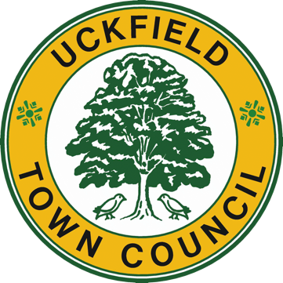 | UCKFIELD TOWN COUNCIL  Council Offices, Civic Centre  Uckfield, East Sussex, TN22 1AE  Tel: (01825) 762774 Fax: (01825) 765757  e-mail: grants@uckfieldtc.gov.uk  Town Clerk – Holly Goring

Dear Sir/Madam

Uckfield Town Council’s Community Grant Programme 2023/24

Please find enclosed a grant application form for 2023/24, as requested.

May I remind you that the closing date for all applications is Sunday 15 January 2023 and any late applications will not be considered.

Confirmation that we have received your application will be sent to you within one week of its receipt. Should you not receive this please contact the Grants Officer prior to the deadline.

I should advise you that all applications will be considered by the Finance Sub-Committee in February 2023. We will confirm the date and time once this has been set, but it usually takes place on a Wednesday evening at 6.30pm.
ALL organisations applying for a grant must provide representation at the meeting. Members of the Finance Sub-Committee will have already read your application, your attendance provides two minutes for you to add any further details and then enable Councillors to ask questions or seek clarification on any matters relating to the application. Please note that should any organisation not have a representative in attendance at the meeting, Councillors may not be able to consider the application, particularly if information is missing.

You should also be advised that any representatives who attend may be required to stay for the duration of the meeting in case additional questions need to be asked.

We look forward to receiving your completed application form and associated documents and I would be grateful if prior to the meeting you could confirm the name of your representative.

Yours faithfully

Grants Officer
Email: grants@uckfieldtc.gov.uk
Telephone: 01825 762774

Please complete the application form associated:

UCKFIELD TOWN COUNCIL

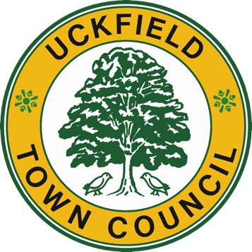

GRANT APPLICATION FORM
Please read the Policy Criteria notes below before making your application. If you are uncertain about how to answer any of the questions on the form, please contact the Town Council on 01825 762774.
Applicants are advised that this form and the information contained in it will be included as part of the Town Council’s public records.

1 | Name of your organisation:
2 | Contact details of applicant:  Name:  Address: | Telephone:  Email:  Website:  Your role in the organisation:
3 | Please confirm the legal status of your organisation | Registered Charity (Local)  Registered Charity (National)  Membership Organisation  Community Interest Company  Other
4 | What are the aims of the organisation?
5 | Please state the number of people involved in your organisation
6 | Approximately what percentage of your members live in Uckfield?
7 | What is the annual subscription, if any?

Grant details

8 | What is the purpose of the grant?
9 | What is the total cost of the project? | £
10 | Amount of grant requested  Grants will only be awarded for forthcoming projects – not retrospectively | £
11 | If the total cost of the project is more than the grant, how will the rest be financed?
12 | How will you be funding the running costs of the project/your group in future years?

13 | Do (or will) you receive any other external funding to support this project? If so, please explain how the Town Council’s funding will bring extra value and demonstrate that the funding will not replace statutory funding or services.

14 | Have you received any funding from the Town Council previously? If so, please provide details.

15 | How does your project directly benefit the people of Uckfield? How many people will be affected?

16 | What additional fundraising events or activities will you be holding this year?

17 | Financial Information
 | Please enclose your latest accepted examined/audited accounts and/or financial projections if a new group and other information as follows:  - Income and Expenditure Account/Financial projections  - Balance Sheet/current Bank Statement  - Club/group constitution or rules  - Breakdown of project costs and supporting estimate | Attached
18 | Is your group registered for VAT | Yes  No

Completed application forms should be returned to:-

grants@uckfieldtc.gov.uk
or
The Grants Officer, Uckfield Town Council, Civic Centre, Uckfield, East Sussex TN22 1AE.

CLOSING DATE FOR APPLICATIONS
Sunday 15 January 2023

If you do not receive a receipt one week from submission of your application, you should contact the council prior to the deadline otherwise your application will be considered inadmissible

Please turn over…

Please note that this application will not be considered unless it is accompanied by a copy of the relevant paperwork. Failing to meet these requirements in full will result in the application being inadmissible.

PLEASE TICK THE FOLLOWING TO CONFIRM YOUR UNDERSTANDING ON SUBMISSION OF YOUR APPLICATION:
☐ I certify that the above information is true to the best of my knowledge and belief, and that I am authorised to make this application for grant aid.
☐ I confirm that I have read the policy criteria and agree to comply with these and understand that if successful, we must undertake to spend the grant on the purpose for which it was awarded.
☐ I acknowledge that any funds awarded, that have not been spent within the financial year, should be returned to Uckfield Town Council.
☐ I acknowledge that we will be required to provide a written update on how the funds were spent against the project criteria, together with any invoices or relevant receipts. This will need to be provided to Uckfield Volunteer Centre as part of their annual evaluation of the community grants programme.
☐ I understand that organisations will be required to acknowledge the Town Council’s support in their publicity material and inclusion of the Town Council’s logo where possible.

I confirm that if a grant is awarded BACs payment should be made payable to:
Name of Bank:
Sort Code:
Account Number:

Signed: Date:

Community Grants Programme 2023/24 - Policy Criteria

Uckfield Town Council, at its discretion and subject to available funding, provides grants and general support to small local groups and organisations which contribute to the welfare of the community by improving or supporting facilities and/or activities in Uckfield Parish. In 2022/23 grants totalled £41,333.75 and were shared amongst local organisations.

The Council assesses applications on their own merits, and the following list of guidelines has been drawn up to help those seeking grants. However full funding is not guaranteed. Grants will not be awarded to commercial or profit-making groups or individuals. Whilst we welcome applications from schools, we will not fund activities or services that the schools have a statutory responsibility to provide.

- Grants will not normally be available to applicants based outside Uckfield unless their activities can be shown to benefit the townspeople of Uckfield.
- The applicant’s activities should be readily available to the community in general.
- Membership of the group should comprise full and part-time residents and adhere to anti-discriminatory legislation.
- The group’s programmes of activities should be made available to the Council, and must comply with all relevant health and safety requirements.
- Current financial status should be confirmed by accepted accounts. New groups, who have been in existence for less than 15 months, must provide financial projections and copies of their most recent Bank or Building Society accounts.
- Applicants must demonstrate their attempts to meet their financial requirements, and that they have applied for financial help from other sources.
- Successful applicants must have a UK Bank or Building Society account in the name of the organisation applying for the grant.
- Applicants can only include any VAT element of their project if they are not able to claim it back from HM Customs and Revenue.
- Unless the grant is for ongoing, revenue activities, we will not fund activities that have started before we confirm our grant.
- Consideration will be given to the applicant’s viability should a grant not be awarded.
- All applicants will be required to co-operate with the Uckfield Volunteer Centre and provide a written report of how the money was spent, in line with the project criteria, for their annual evaluation of the programme
- If applications for grants are incomplete by the closing date they are unlikely to be accepted.
- The decision of Uckfield Town Council is final.
- A representative of the applicant organisation must attend the meeting of Finance Sub-Committee in February 2023 to be available to answer questions. Failure to do so will result in the application not being considered. The office must be informed prior to the meeting of any exceptional circumstances where attendance is not possible.
- Members of the Finance Sub-Committee will have already read your application, your attendance provides two minutes for you to add any further details and then enable Councillors to ask questions or seek clarification on any matters relating to the application.
- Any unspent money must be returned to Uckfield Town Council.
- As a condition of receiving a grant, organisations will be required to acknowledge the Town Council’s support in their publicity material. (Prior viewing necessary).
- Grants cannot be made retrospectively.

